**Methodology of Airbnb New York Data-set**

**Introduction**:

As a data analyst at Airbnb, the recent decline in revenue has prompted the company to prepare for a rebound in travel as restrictions are lifted. With the aim of capitalizing on this changing landscape, data analysis will play a critical role in identifying trends, understanding customer behavior, and implementing targeted marketing strategies to ensure Airbnb's successful recovery and growth in the post-pandemic era.

**Objectives**:

The officials at Airbnb are primarily interested in gaining insightful information from the dataset by examining various aspects. They will be able to make wise decisions and put into practice tactics that can increase the company's revenue thanks to these insights.

**Problem**:

The different leaders at Airbnb want to understand some important insights based on various attributes in the dataset so as to increase the revenue such as -

Which type of hosts to acquire more and where?

The categorisation of customers based on their preferences.

What are the neighbourhoods they need to target?

What is the pricing ranges preferred by customers?

The various kinds of properties that exist w.r.t. customer preferences.

Adjustments in the existing properties to make it more customer-oriented.

What are the most popular localities and properties in New York currently?

How to get unpopular properties more traction? and so on...

Based on the analysis, we need to give two presentations to the following groups.

Presentation - I

* Data Analysis Managers: These people manage the data analysts directly for processes and their technical expertise is basic.
* Lead Data Analyst: The lead data analyst looks after the entire team of data and business analysts and is technically sound.

Presentation - II

* Head of Acquisitions and Operations, NYC: This head looks after all the property and host acquisitions and operations. Acquisition of the best properties, price negotiation, and negotiating the services the properties offer falls under the purview of this role.
* Head of User Experience, NYC: The head of user experience looks after the customer preferences and also handles the properties listed on the website and the Airbnb app. Basically, the head of user experience tries to optimise the order of property listing in certain neighbourhoods and cities in order to get every property the optimal amount of traction.

**Data preparation on Python:**

Let’s understand the Data:

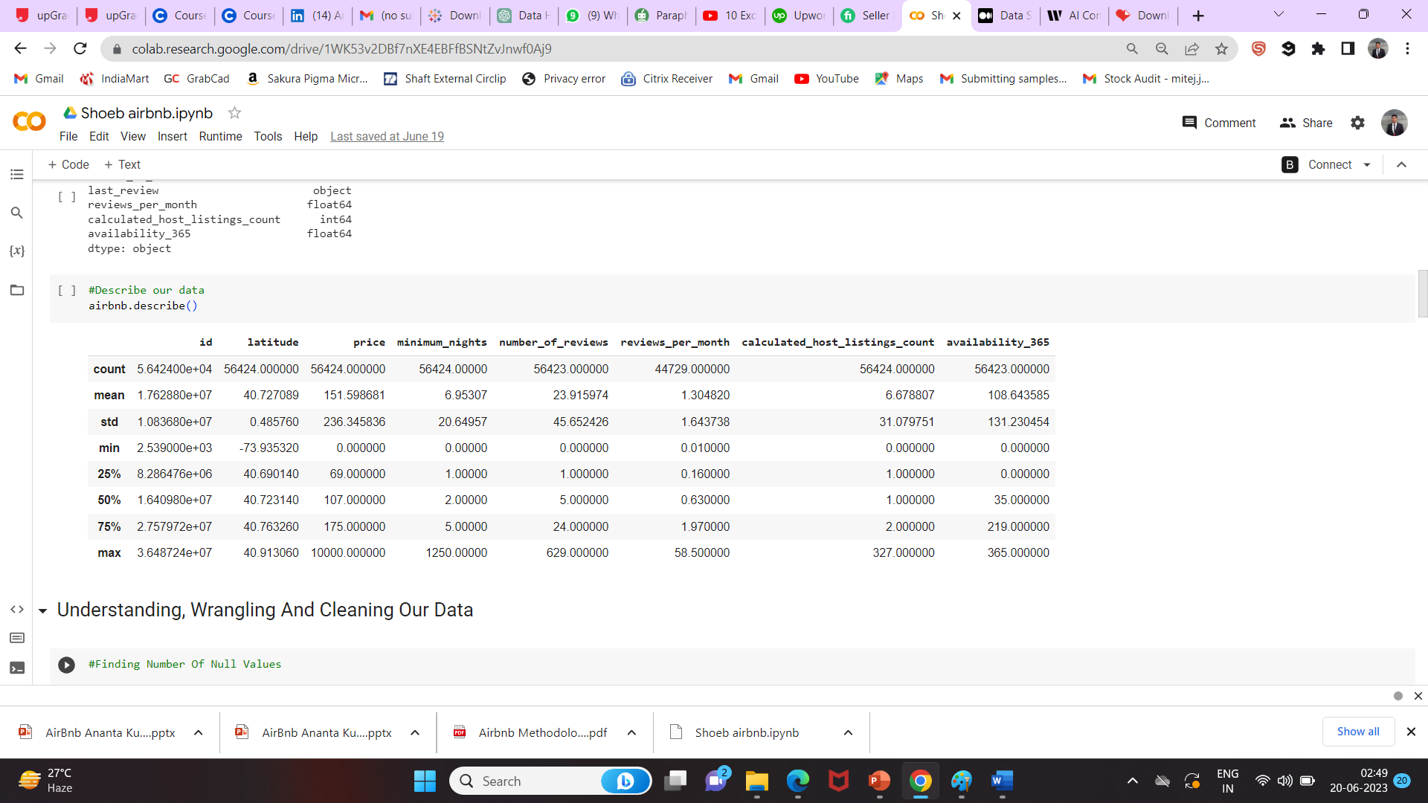

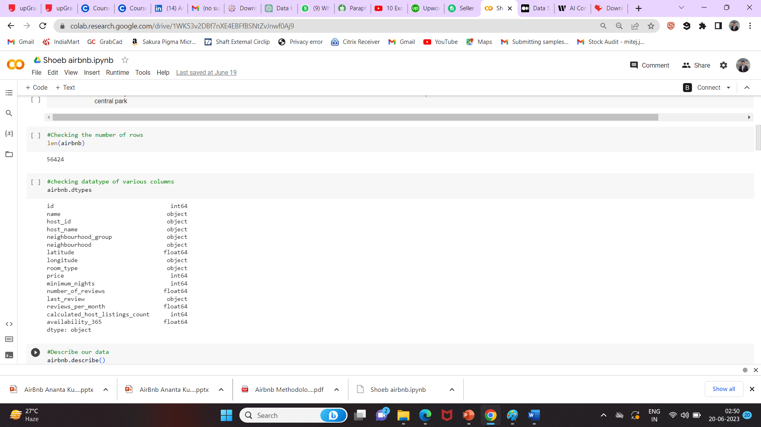

Replace NAN values with zero

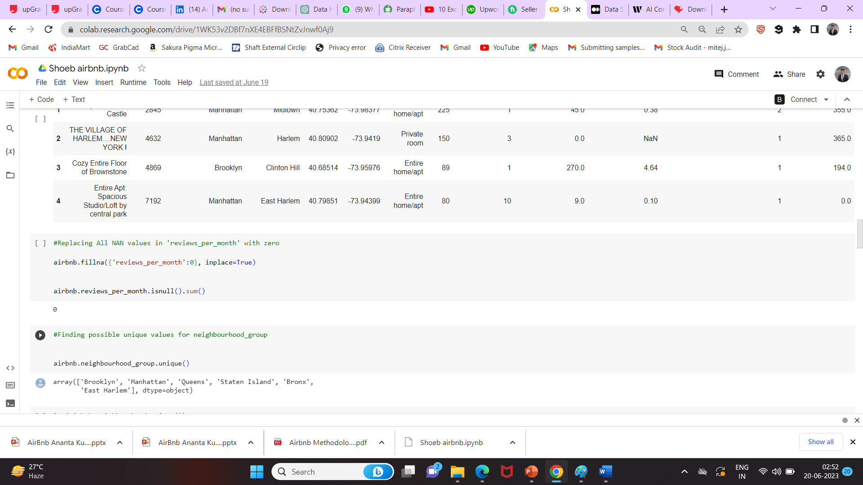

Now let’s go ahead towards analysis

First, we analyzed the data in the dataset using Python to gain a better understanding of its contents.

We then dealt with missing values by using the median as a replacement. To ensure fairness, we identified an equal number of null values.

Next, we separated the dataset's columns into two types: categorical (representing qualitative data) and numerical (representing quantitative data).

Finally, we checked for any outliers in the six continuous columns (columns with continuous numerical data) and took necessary actions to handle them appropriately, ensuring that they did not adversely affect our analysis.

**Data Visualization:**

We employed Tableau, a powerful data visualization tool, to create visually appealing representations of various attributes. By visualizing the data, we gained valuable insights and a better understanding of the factors influencing Airbnb's revenue.

we took following steps for whole visualization process:

* I started by connecting our cleaned and prepared dataset to Tableau. This allowed me to access the necessary data for the visualizations.
* Then, I simply dragged and dropped the relevant fields from the data pane onto the Tableau canvas. I selected the appropriate dimensions for the X and Y axes, assigned measures to size, color, or shape properties, and applied filters as needed.
* Based on our visualization design plan, I chose the right visualization types from Tableau's library. I used bar charts, line graphs, scatter plots, and maps to represent the data effectively.
* I customized the visualizations by adjusting properties like axis ranges, labels, titles, and legends. I also modified colors, shapes, and sizes to make the visualizations more visually appealing and highlight important information.
* To make the visualizations interactive, I added features such as filters that allowed users to select specific dimensions or subsets of data. I created dashboards that combined multiple visualizations for a comprehensive view. I also used actions to link views and enable drill-down capabilities.
* Throughout the process, I continuously tested and refined the visualizations. I made sure they accurately represented the data and provided meaningful insights. I also sought feedback from stakeholders to make necessary improvements.

**Data assumptions:**

'Reviews per Listing' was used as the popularity metric to get data on consumer preferences.

The assumption is that the "Number of reviews" is a baseline indicator of customer preferences.

Calculation for Total Earnings was done as follows:

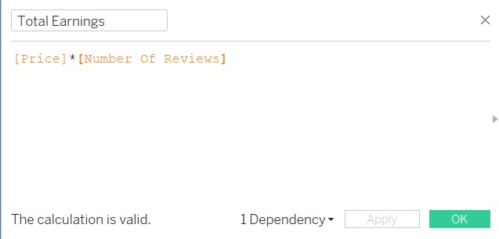

**Top 10 Hosts with maximum number of earnings:**

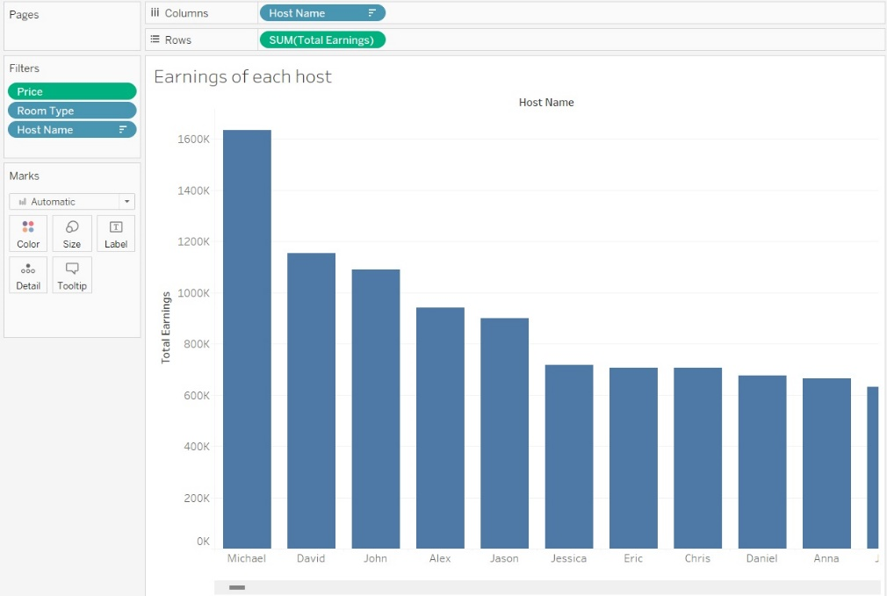

* The graphs shows the top 10 hosts which are earning maximum money
* Michael, David and John are top 3 earners who are earning more and most of their properties are in Manhattan
* We have identified the top 10 hosts who are making the most money. Among them, there is one standout host named Michael. He has a large number of properties and earns a significant income. This is because he operates in Manhattan, which is a bustling area attracting tourists and financial enthusiasts throughout the year.

**Most properties in New York by host:**

* The graph reveals the top 10 hosts in New York City with the highest number of properties.
* Among them, Michael, David, and John hold the first, second, and third positions, respectively. Michael has an impressive 335 properties, followed by David with 309 properties and John with 250 properties.
* These hosts have established a significant presence in the Airbnb market in New York City, demonstrating their success and ability to manage a large number of properties.

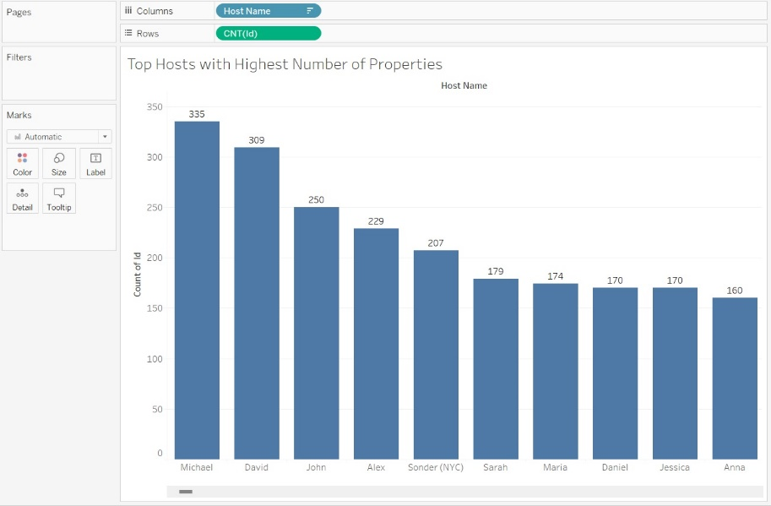

**Average earning of hosts:**

* The graph provides clear evidence that the majority of people tend to allocate their expenditure within the range of $30 to $300. This suggests that most individuals are inclined to spend their money on accommodations falling within this price bracket.
* Furthermore, the average earnings of hosts in the given context appear to be around $8,000 to $10,000. This figure represents the typical income generated by hosts from their rental properties.
* Interestingly, the graph also highlights a distinct trend regarding host earnings. Specifically, it indicates that hosts who set their average price at $160 or higher tend to earn more than $11,000. This suggests a correlation between higher pricing and increased earning potential for hosts.

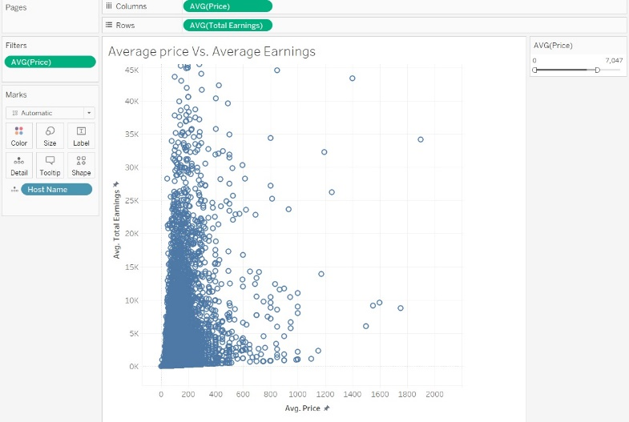

**Average price at Various neighborhood groups:**

* The graphs shows Manhattan has the most Avg price for all 3 categories of Room Type, For entire home – 235$, for Private room – 110$, For shared Rooms – 78$
* At all Neighborhood Groups Shared room has the lowest Avg price.

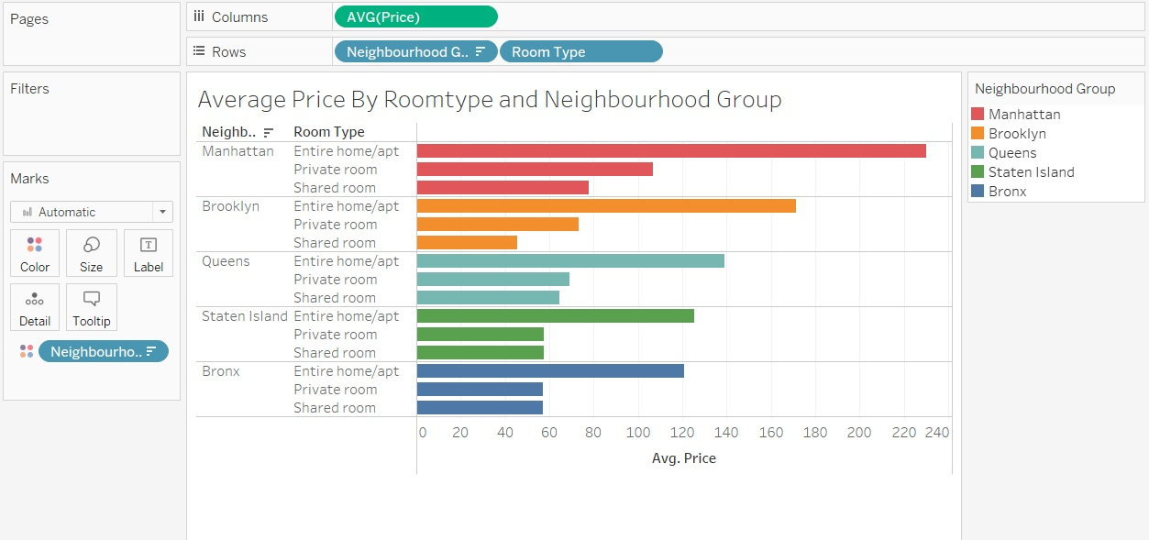

**Average price at Various neighborhood groups:**

* When considering the average price across all three types of accommodations (Entire-230$, Private-106$, Shared-78$), Manhattan consistently ranks at the top, indicating higher prices compared to other neighborhood groups.
* On the other hand, the Bronx consistently ranks at the bottom for charging the lowest prices in two aspects (Entire-120.8$, Private-57.1$, Shared-56.9$), suggesting more affordable accommodations in this neighborhood group.
* To boost sales and improve performance, neighborhood groups other than Manhattan should consider revising their marketing strategies. This implies the need for alternative approaches to attract more customers and increase bookings.

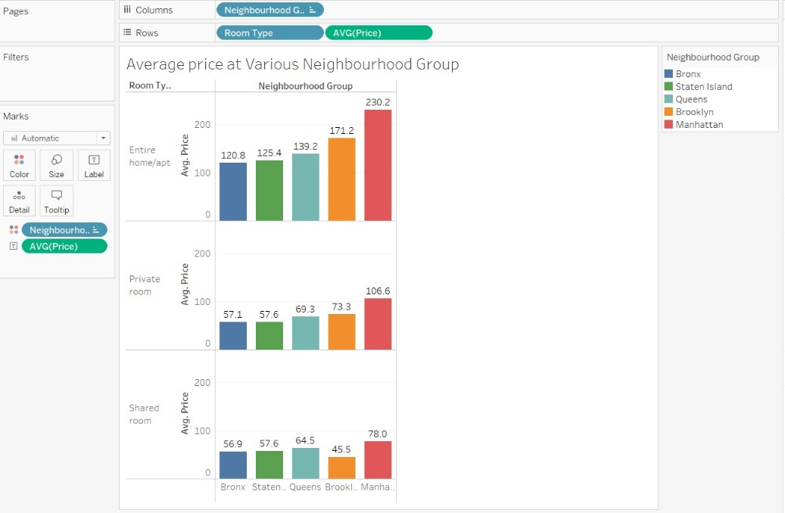

**Average price preferred by customers:**

The graphs shows that average price in dollars for buying an entire home or apartment and preferred by customers is 151$

For private room and shared room is 70$ and 45$ accordingly

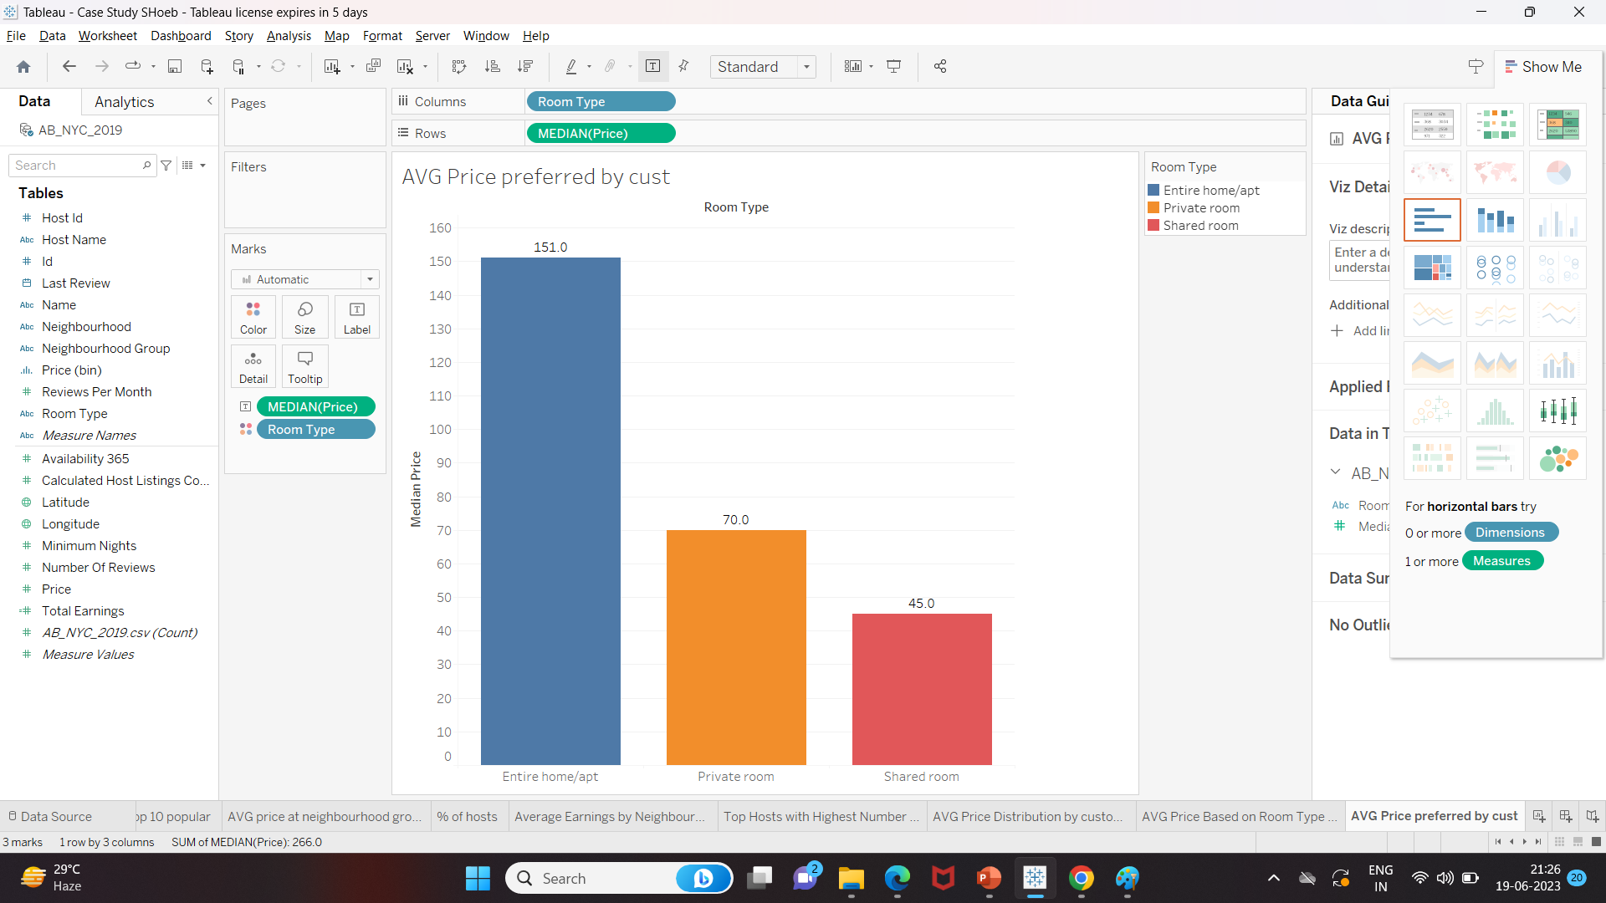

**Concentration of Airbnb hosts across various neighborhoods:**

* The data reveals the distribution of hosts with Airbnb properties across different neighborhood locations in New York.
* Manhattan has the highest percentage of hosts with Airbnb listings, accounting for 41.82% of the total.
* Brooklyn follows closely in second place, with 41.04% of hosts having properties listed on Airbnb.
* Queens ranks third, with approximately 13.53% of hosts having properties listed on Airbnb.

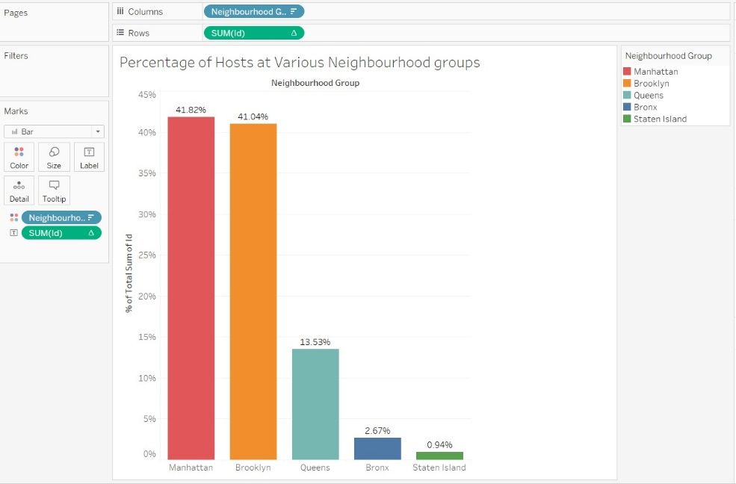

**Room types preferred by the customers:**

* Based on the Number of Reviews the graph shows that 51% people preferred to stay at Entire home apartment, 47.3% people preferred to stay at private rooms and only 1.7% people preferred to stay at shared rooms
* To boost the number of bookings for shared rooms, Airbnb could concentrate on promoting them through discounted offers. By providing discounts specifically for shared accommodations, Airbnb can encourage more users to choose this option and increase the overall booking rate for shared rooms.

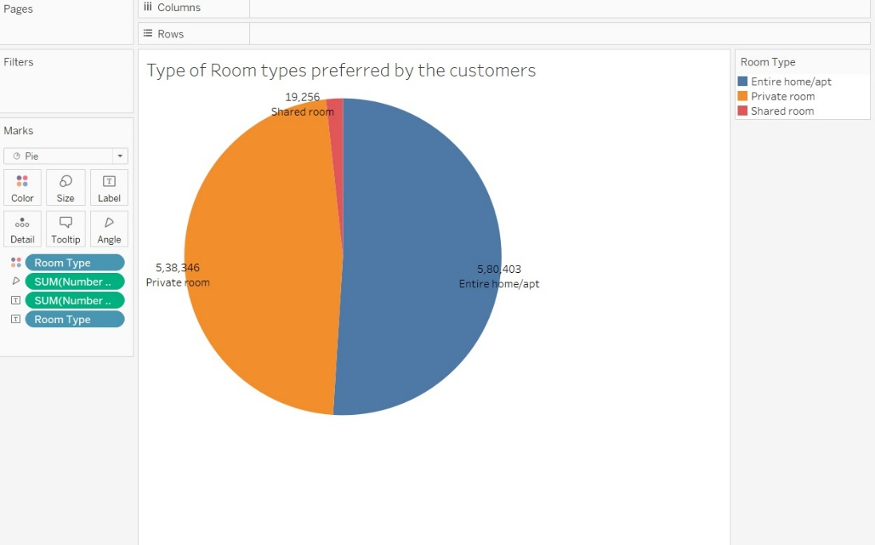

**Trend of reviews in last 8 years**

* The data reveals an interesting pattern regarding the number of reviews over the years. In 2012, we can observe that the number of reviews is relatively low compared to other years.
* However, as we move forward in time, there is a consistent upward trend in the number of reviews. It indicates a growing level of engagement and feedback from customers.
* The year 2019 stands out prominently, as there is a significant surge in the number of reviews. This can be attributed to the increased usage of technology by customers.
* This upward trend in reviews reflects the growing reliance on technology and the digital landscape, where customers find it convenient to express their opinions and provide feedback.
* It is evident that customers are actively participating in the sharing economy, where their feedback plays a crucial role in shaping the reputation and success of Airbnb accommodations.

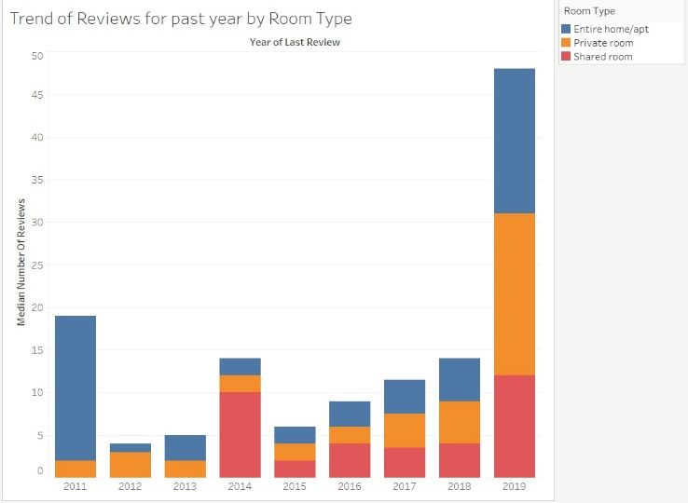

**Maximum earning w.r.t neighborhood:**

* The data reveals the distribution of earnings among hosts in different neighborhood locations in New York.
* Manhattan emerges as the top-earning neighborhood, with 49.17% of hosts generating the highest earnings from their Airbnb properties.
* Brooklyn follows closely in second place, with 39.58% of hosts achieving significant earnings from their listings.
* Queens ranks third, with approximately 9.14% of hosts earning notable income from their Airbnb properties.
* Staten Island represents a smaller portion of the earnings, with 1.47% of hosts generating income from their listings.

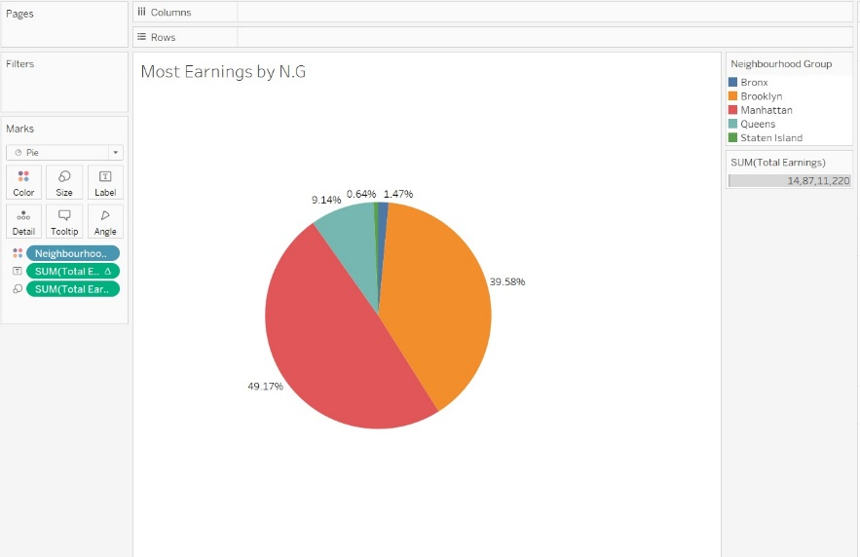

**Neighborhoods need to be targeted:**

* Airbnb can target specific neighborhoods like Williamsburg, Brooklyn, Midtown Manhattan, Bedford, Brooklyn, East Village, Manhattan, and Hell's Kitchen to increase sales. Here's why:
* Vibrant and Trendy: These neighborhoods are known for their vibrant and trendy atmospheres, attracting young professionals and tourists seeking unique experiences.
* Cultural and Artistic Scene: They offer a thriving cultural and artistic scene with art galleries, music venues, and theaters, making them attractive to creative individuals.
* Dining and Nightlife: These areas boast a wide variety of trendy restaurants, cafes, bars, and nightlife options, catering to different tastes and preferences.
* Proximity to Attractions: Many of these neighborhoods are located close to popular landmarks, tourist attractions, and entertainment venues, providing convenience and easy access for visitors.

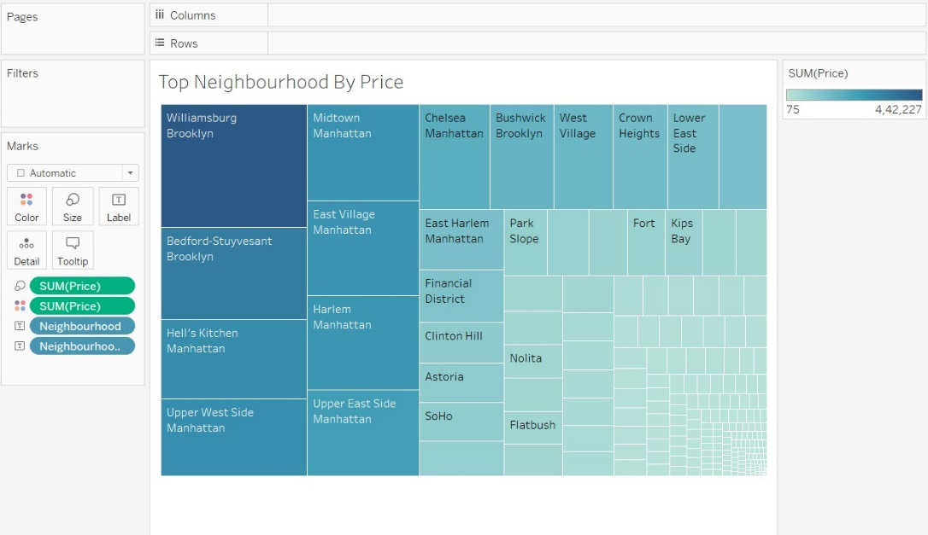

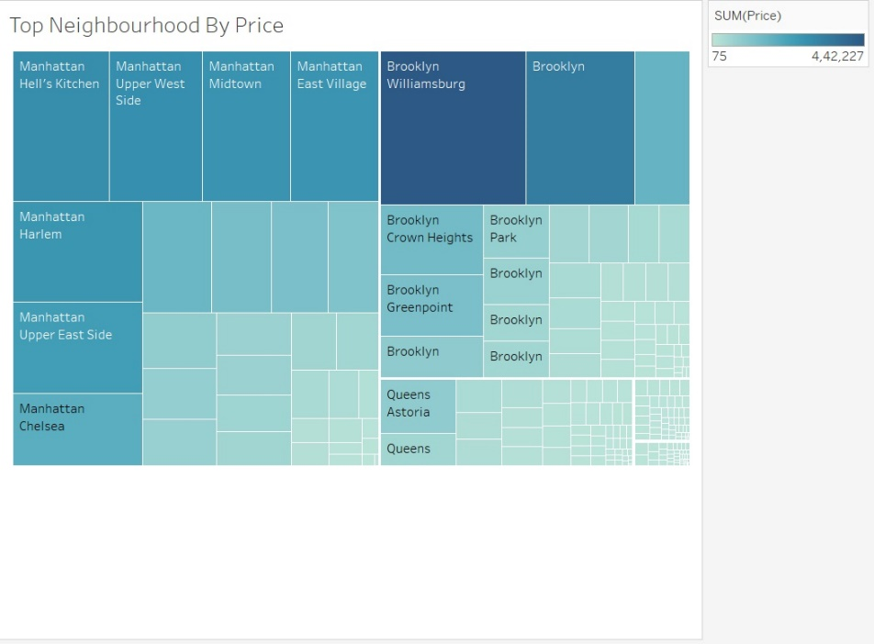

**Density of properties in New York:**

* From the map, we can observe that Manhattan, Brooklyn, and Queens are highly popular locations.
* These areas attract a significant number of people and have a strong demand for various reasons, such as their vibrant atmosphere, cultural offerings, and proximity to attractions.
* The popularity of these boroughs suggests that they are preferred choices for residents and tourists alike.

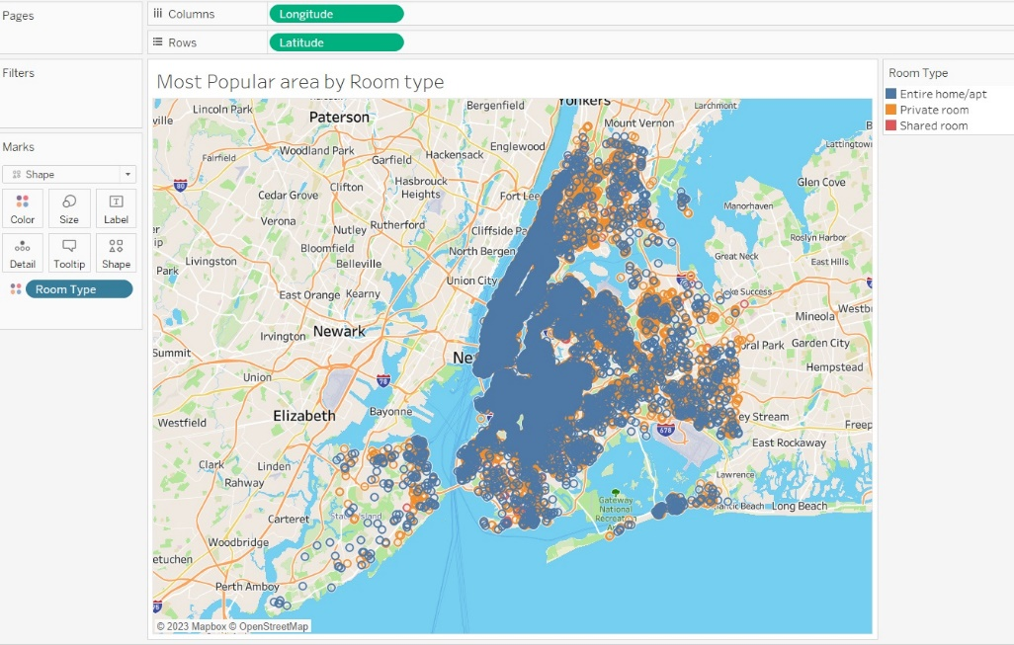

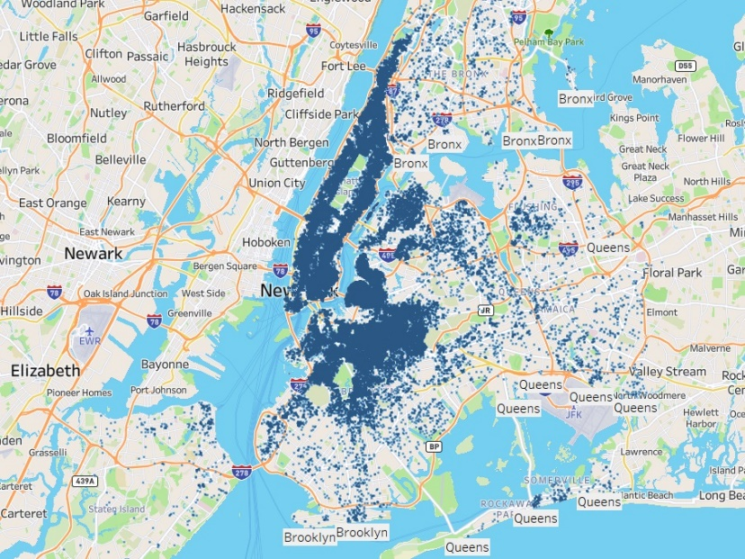

**Top unpopular properties in New York:**

* Here are the top 10 unpopular locations in New York City, and the reasons for why they are unpopular:
* Remote and Isolated: These locations are situated at the corners or outskirts of the city, away from popular attractions and bustling areas.
* Lack of Tourist Attractions: These areas often lack significant tourist attractions or landmarks, making them less appealing for visitors.
* Limited Accessibility and Amenities: These locations may have limited transportation options, longer travel times to reach popular destinations, and a scarcity of amenities such as restaurants, shops, and entertainment venues.

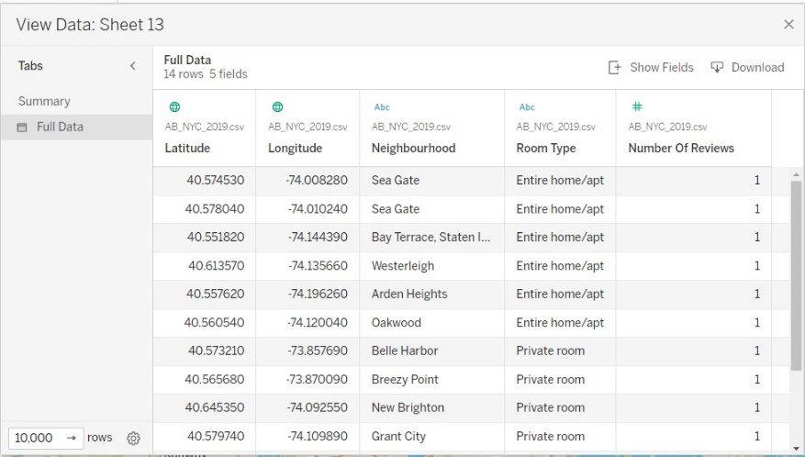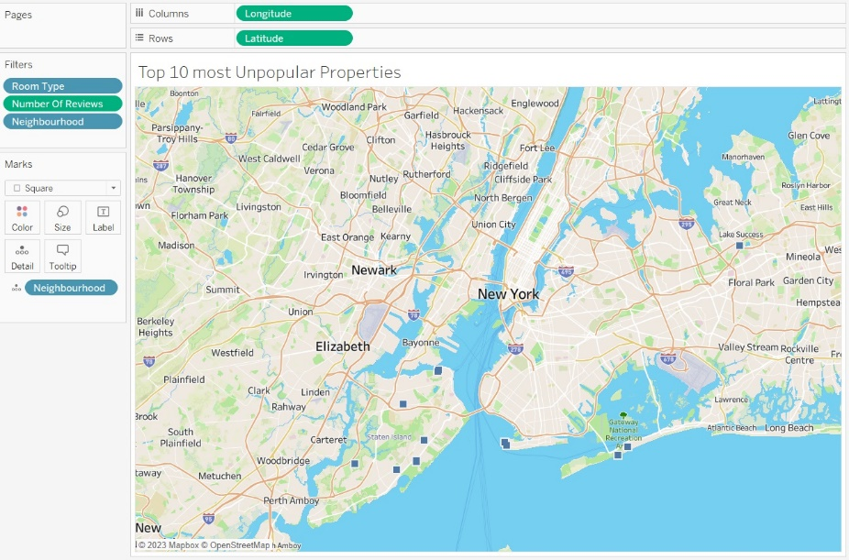

**Top popular properties in New York:**

* These neighborhoods in New York City have become popular choices for Airbnb properties due to a variety of reasons:
* Rich Cultural Heritage: These neighborhoods are known for their deep cultural roots and historical significance, attracting travelers who seek an immersive experience steeped in the local culture and traditions.
* Lively Arts and Music Scene: With an abundance of art galleries, street art, music venues, and live performances, these neighborhoods offer a vibrant and dynamic atmosphere that appeals to art enthusiasts and music lovers alike.
* Culinary Delights and Nightlife: The presence of diverse dining options, ranging from local eateries serving authentic cuisine to trendy restaurants offering innovative dishes, along with a buzzing nightlife scene, make these neighborhoods a magnet for food enthusiasts and those seeking evening entertainment.
* Convenient Access to Attractions: Situated in close proximity to popular landmarks, attractions, and entertainment venues, these neighborhoods offer easy access to the city's iconic sights, allowing visitors to make the most of their stay and explore the vibrant surroundings.

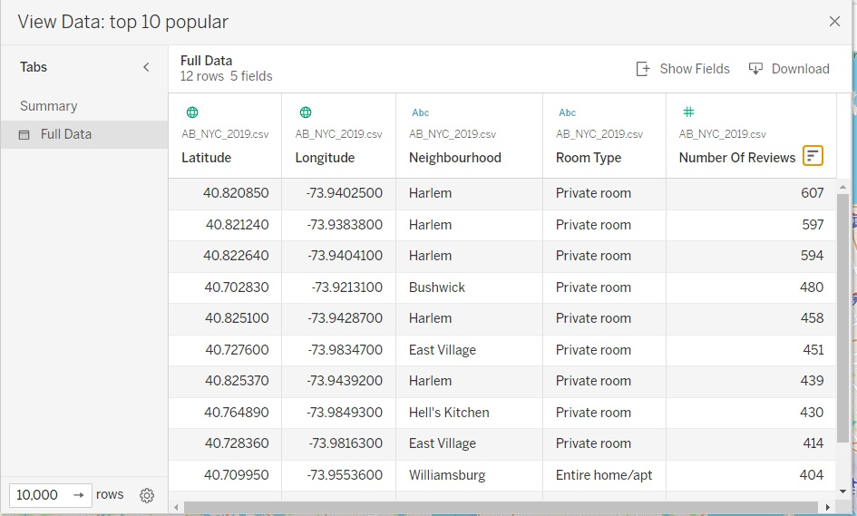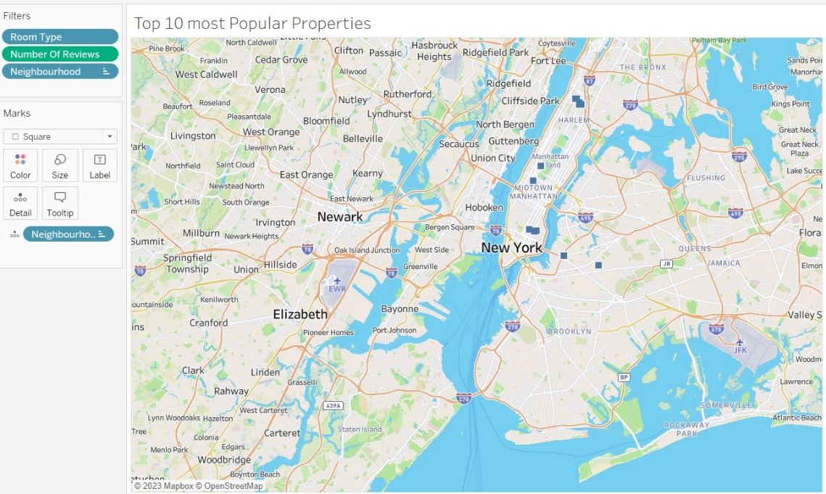

**Price distribution by customers:**

* The majority of customers show a preference for spending their money within the range of $40 to $140.
* Customers tend to allocate their budget within this range when selecting accommodations, indicating a common price point that is considered reasonable and attractive.
* However, it is worth noting that there is a segment of customers who are willing to pay more for a luxury experience.
* The willingness to spend more reflects the desire for a luxurious and upscale experience, indicating that some customers prioritize luxury and are willing to pay a premium for it.

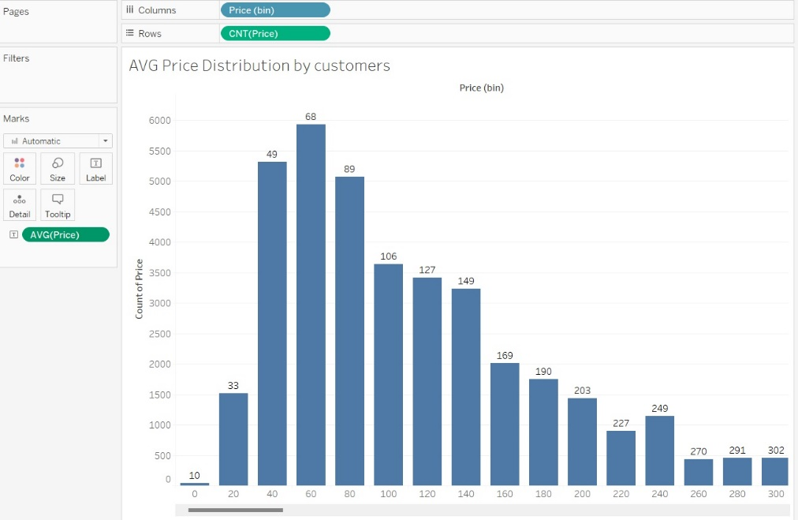

**AVG price for room types w.r.t neighborhood:**

* Manhattan and Brooklyn excel in earnings for all room types, demonstrating their marketing leadership.
* However, shared rooms are not as successful in these neighborhoods.
* This suggests a lower demand or preference for shared accommodations in Manhattan and Brooklyn.

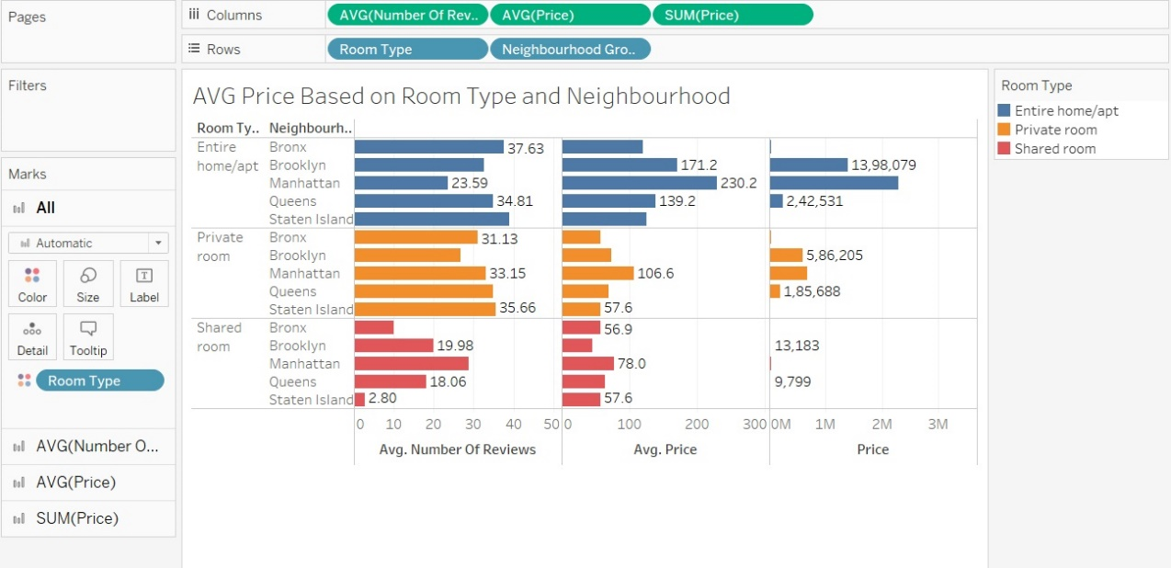

**Average earning by neighbourhood groups:**

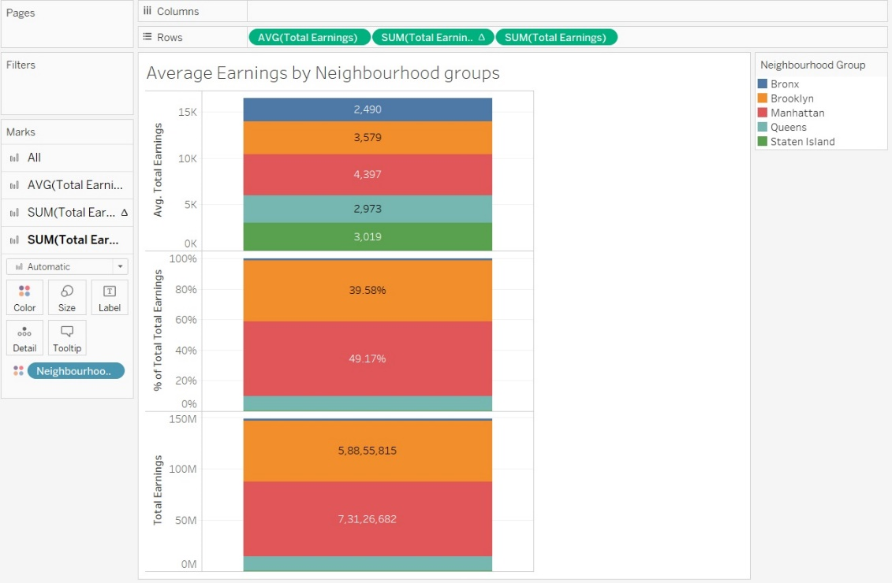

**Adjustments to make existing properties more customer-oriented:**

* Improve Marketing Strategies: Develop new and effective marketing campaigns to increase sales, especially in areas other than Manhattan and Brooklyn.
* Attractive Pricing: Adjust prices to match customer preferences, targeting the $40 to $140 range, which is most popular among customers.
* Enhance Property Amenities: Upgrade property amenities to meet the expectations of modern travelers, providing comfortable and convenient features.
* Compelling Property Listings: Improve property descriptions and showcase unique features to attract potential guests.
* Exceptional Customer Service: Prioritize delivering excellent customer service, promptly addressing inquiries and providing personalized attention to guests.

**Recommendations:**

* Focus on promoting shared accommodations with discounted offers to increase bookings for shared rooms.
* Consider acquiring properties within the desired price range ($40 - $140), focusing on private rooms in Manhattan and Brooklyn, and entire homes in the Bronx and Queens.
* Brooklyn has shown potential for growth, with an average cost between $100-$140 and a significant number of listings.
* Explore coastal locations and new construction areas to attract more bookings from customers.
* Prioritize marketing efforts in prime locations such as Manhattan and Brooklyn, where there is higher interest from potential guests.
* Analyze seasonal trends and target marketing strategies during peak seasons, such as the summer months, to capitalize on increased tourism.
* Identify and address issues at low-performing sites with low availability and review counts to improve customer experience.
* Diversify accommodation types by expanding the availability of shared rooms in addition to private rooms and entire apartments.
* Collaborate with top hosts who have received high review counts to enhance credibility and attract more guests.

**Key insights from the data analysis:**

* Central Locations: Visitors prefer staying in the center of New York City to enjoy its beauty.
* Limited Shared Rooms: Shared rooms have lower prices and higher availability, despite being less in number.
* Reviews and Pricing: Lower-priced accommodations receive more reviews per month compared to expensive ones.
* Costly and Popular Neighborhoods: Manhattan and Brooklyn are expensive and popular among tourists.
* Minimum Stay and Price: Higher-priced options have shorter minimum stay requirements.
* Target Prime Locations: Focus marketing efforts on prime locations like Manhattan and Brooklyn.